Cognitive Synonyms

🔹 What is Cognitive Synonyms
# Source: Chatgpt (GPT-4-turbo) at [7/30/2025]
Cognitive synonyms are true or near-perfect synonyms—words that have identical or very close meanings and can often be used interchangeably without significantly altering the truth value of a sentence.

🧠 Definition:
# Source: Chatgpt (GPT-4-turbo) at [7/30/2025]
Cognitive synonyms are words that express the same concept or idea and can usually be substituted for one another in most contexts without changing the meaning of the sentence.
They are sometimes also called true synonyms in a semantic or cognitive sense.

📌 Key Characteristics:
# Source: Chatgpt (GPT-4-turbo) at [7/30/2025]
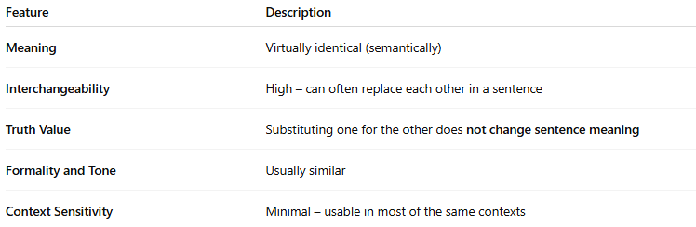
Feature | Description
Meaning | Virtually identical (semantically)
Interchangeability | High – can often replace each other in a sentence
Truth Value | Substituting one for the other does not change sentence meaning
Formality and Tone | Usually similar
Context Sensitivity | Minimal – usable in most of the same contexts

📚 Examples of Cognitive Synonyms:
# Source: Chatgpt (GPT-4-turbo) at [7/30/2025]
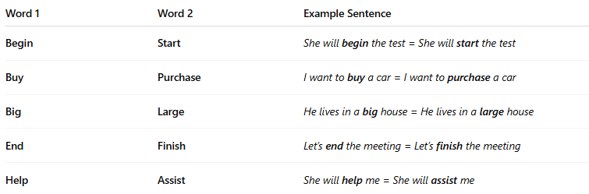
Word 1 | Word 2 | Example Sentence
Begin | Start | She will begin the test = She will start the test
Buy | Purchase | I want to buy a car = I want to purchase a car
Big | Large | He lives in a big house = He lives in a large house
End | Finish | Let’s end the meeting = Let’s finish the meeting
Help | Assist | She will help me = She will assist me

❗ Note:
# Source: Chatgpt (GPT-4-turbo) at [7/30/2025]
Even cognitive synonyms may vary slightly in style (e.g., buy vs. purchase), but they do not affect the core meaning of the statement.

🔁 Comparison with Other Types:
# Source: Chatgpt (GPT-4-turbo) at [7/30/2025]
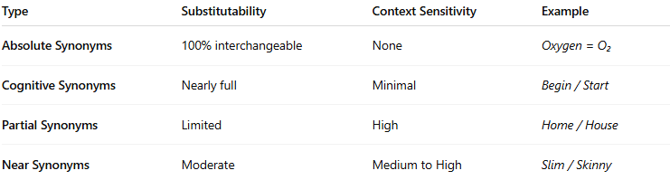
Type | Substitutability | Context Sensitivity | Example
Absolute Synonyms | 100% interchangeable | None | Oxygen = O₂
Cognitive Synonyms | Nearly full | Minimal | Begin / Start
Partial Synonyms | Limited | High | Home / House
Near Synonyms | Moderate | Medium to High | Slim / Skinny

